[](https://drive.google.com/file/d/1zqiRFh6VUOb0VX0FDb7V7IGLKIV0suxm/view?usp=sharing)

<https://drive.google.com/file/d/1zqiRFh6VUOb0VX0FDb7V7IGLKIV0suxm/view?usp=sharing>

[](https://drive.google.com/file/d/1zrRgFCmXmUTeb8g4ykUoPDNV_Q9Mn5wQ/view?usp=sharing)

<https://drive.google.com/file/d/1zrRgFCmXmUTeb8g4ykUoPDNV_Q9Mn5wQ/view?usp=sharing>

[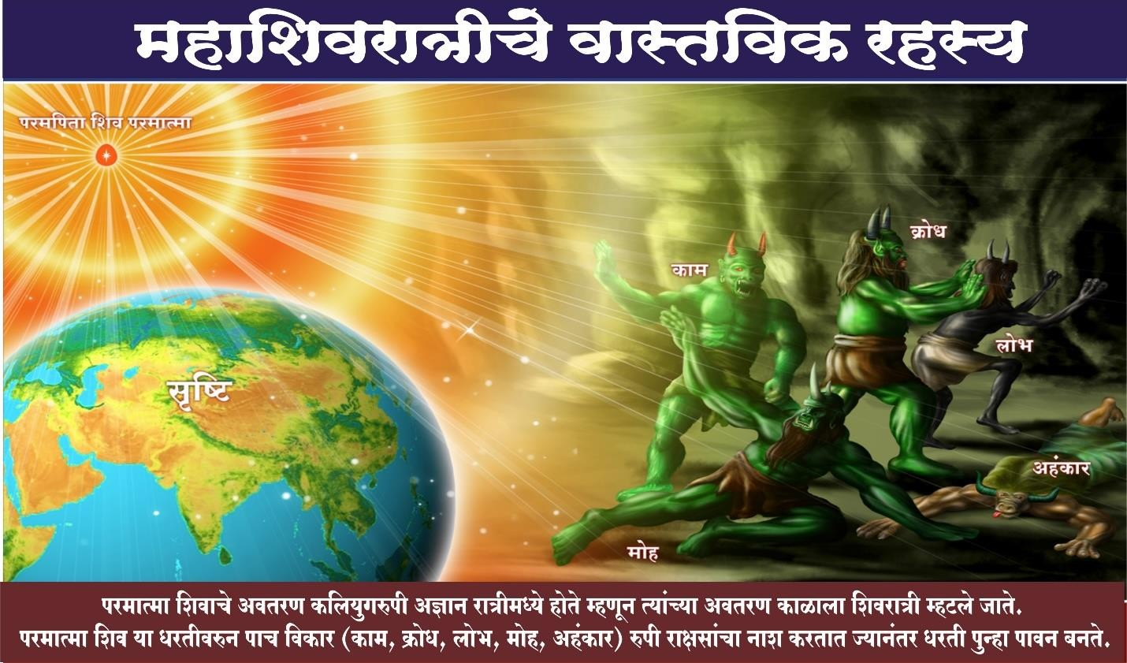](https://drive.google.com/file/d/1zsJvH8uKwXO5wp6YCPKv9N9O4EpwJHAN/view?usp=sharing)

<https://drive.google.com/file/d/1zsJvH8uKwXO5wp6YCPKv9N9O4EpwJHAN/view?usp=sharing>

[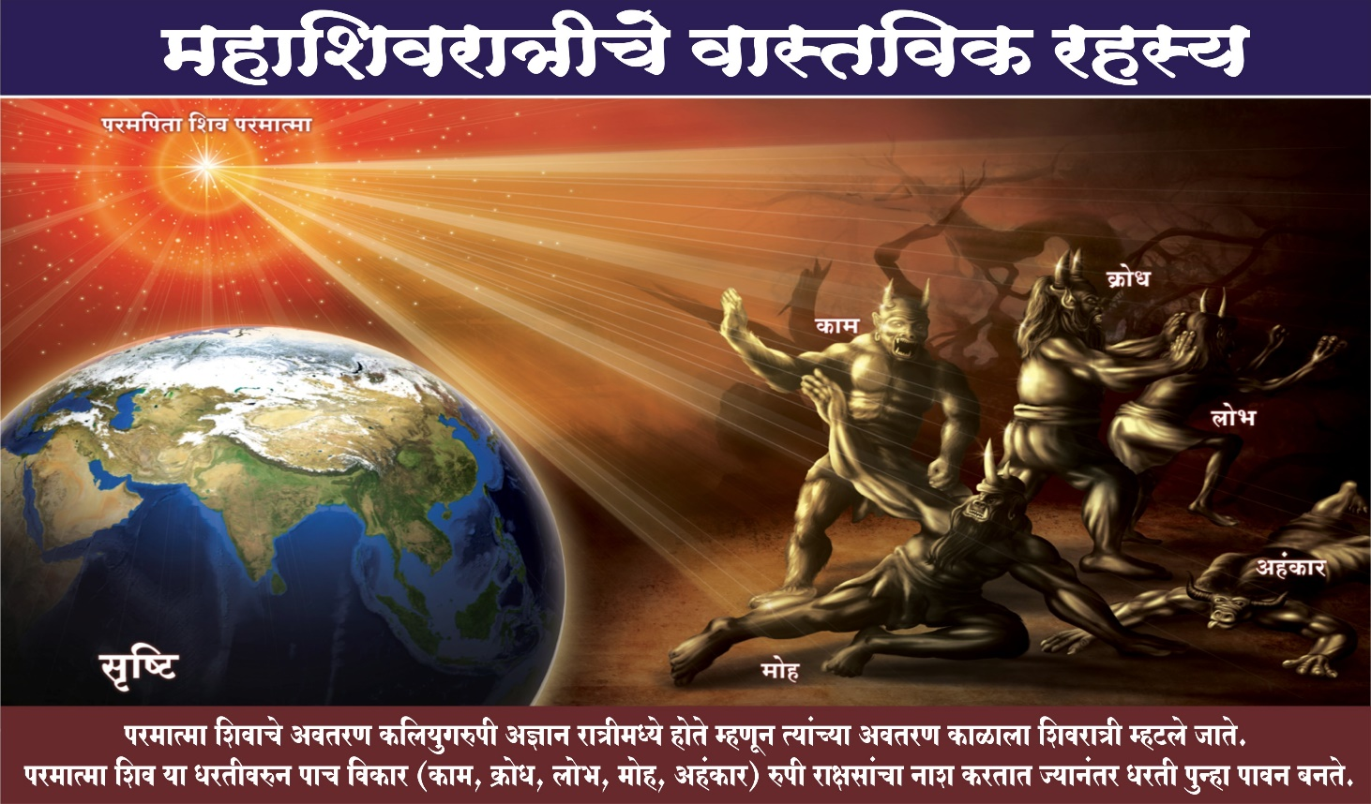](https://drive.google.com/file/d/1ztdQxv9WkdYE_NMyQYfVgDHtnRtd_4Nq/view?usp=sharing)

<https://drive.google.com/file/d/1ztdQxv9WkdYE_NMyQYfVgDHtnRtd_4Nq/view?usp=sharing>

[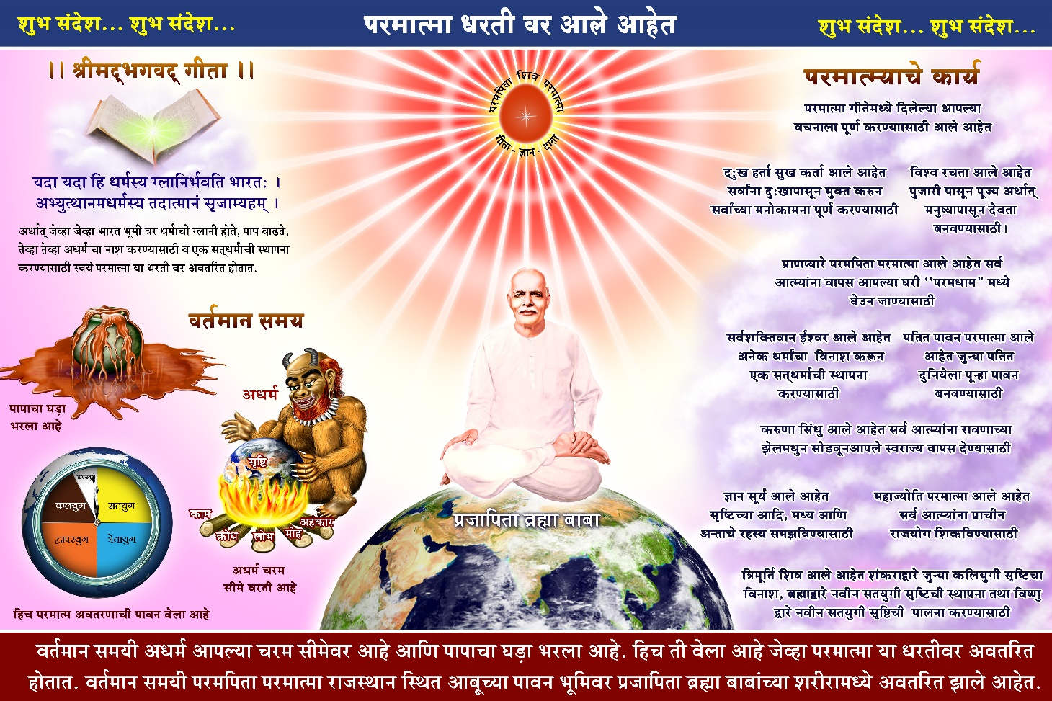](https://drive.google.com/file/d/1zrZgOB0Iu4WjQ-dOngElDN9sVl0WhBAx/view?usp=sharing)

<https://drive.google.com/file/d/1zrZgOB0Iu4WjQ-dOngElDN9sVl0WhBAx/view?usp=sharing>

[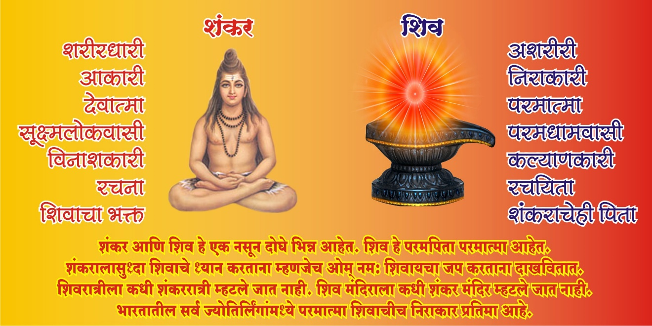](https://drive.google.com/file/d/1zqZE8suoS2Kbt4lhN-mhQIJQnFnfsDuo/view?usp=sharing)

<https://drive.google.com/file/d/1zqZE8suoS2Kbt4lhN-mhQIJQnFnfsDuo/view?usp=sharing>

[](https://drive.google.com/file/d/1zqEKSFJUgxijyM7pUdDwL9gKBKdgOAad/view?usp=sharing)

<https://drive.google.com/file/d/1zqEKSFJUgxijyM7pUdDwL9gKBKdgOAad/view?usp=sharing>