[](https://drive.google.com/file/d/120gyTh_OXzNZlFbJlqytLd_yiaAyely6/view?usp=sharing)

<https://drive.google.com/file/d/120gyTh_OXzNZlFbJlqytLd_yiaAyely6/view?usp=sharing>

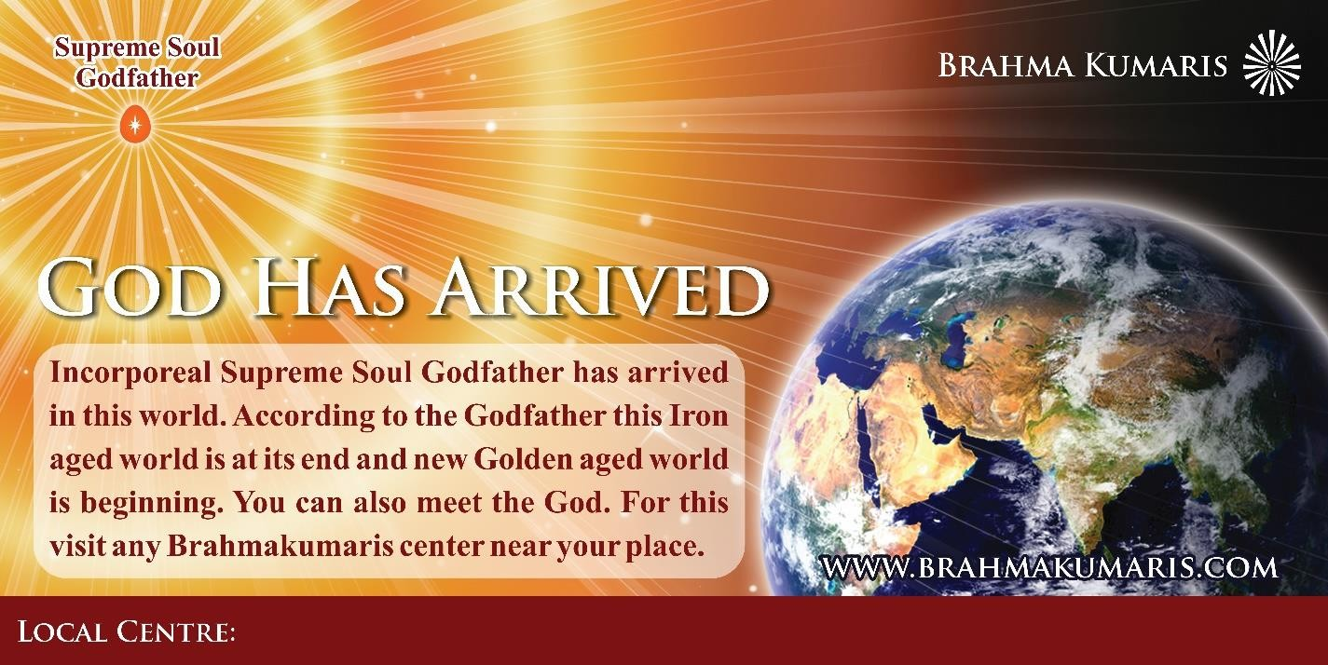

<https://drive.google.com/drive/folders/1zw8-Vh1AteVxjW4SNfVxJRhytsL5UQGz?usp=sharing>

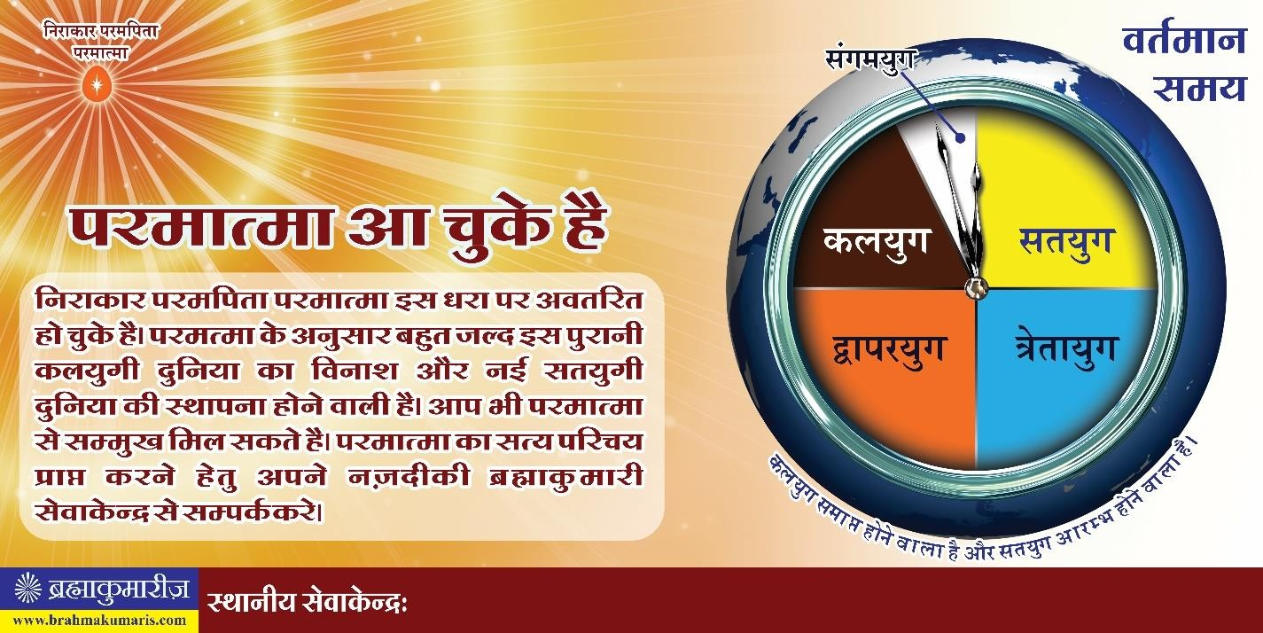

<https://drive.google.com/drive/folders/1zw8-Vh1AteVxjW4SNfVxJRhytsL5UQGz?usp=sharing>